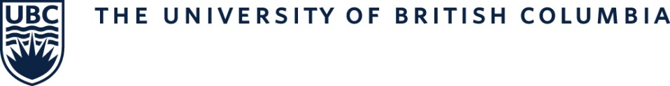
Document #2: MOT Program - Northern and Rural Cohort (NRC) Application Form
If you indicated on the online MOT application that you are interested in being considered for the Northern and Rural Cohort for the MOT program, please complete both this document (Document #2: Northern and Rural Cohort (NRC) Application Form) and Document #1: Northern and Rural Lived Experiences Form. NRC forms are to be uploaded as separate documents to the application portal by the application submission deadline (do not merge both documents into one). Late applications will not be accepted.
Last Name, First Name:
Birthdate (DD/MM/YY):
Email address:
Student number (if known):

Section 1: Decision to Apply to the Northern and Rural Cohort:
Please explain your reasons for choosing to apply to the Northern and Rural Cohort of the MOT program, as well as experiences that contributed to this decision.
Please limit your response to no more than 250 words:

Section 2: Affinity for Rural Training and Practice
As part of the Northern and Rural Cohort you will complete a minimum of 3 out of 5 of your placements in northern and rural communities. Discuss some of the opportunities, challenges, and rewards you think you will experience while on placement in a rural community.
Please limit your response to no more than 250 words:

